Project Overview (Updated)
Problem: Your father runs a freelance photography business covering weddings, events, school graduations, and university graduations. After editing photos from an event, students must manually search through 10,000+ photos to find their own — a process taking 5–6 hours per student. This creates a major bottleneck in the business, especially during graduation season when many students need their photos quickly.
Proposed Solution: A locally-installed face detection and recognition system, deployed across your father's shop and his workers' workstations, that automatically indexes all event photos by face and lets students retrieve their own photos in seconds by uploading a selfie — no manual searching required.
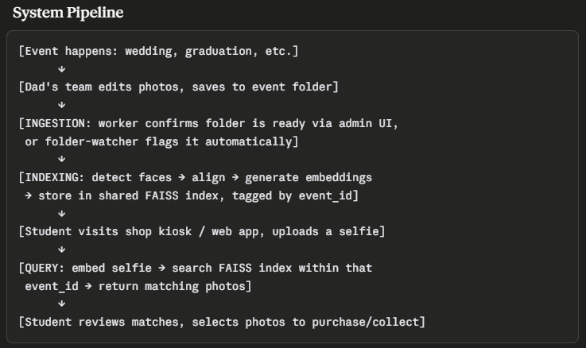
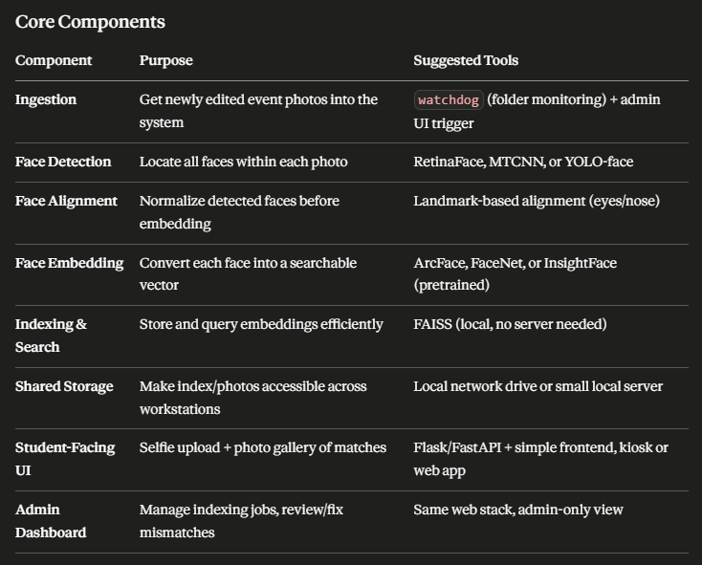
Key Design Considerations
- Fully local / offline: No cloud upload — all processing, storage, and search happen on your dad's own hardware, which is also a strong privacy selling point.
- Event-scoped search: Each event's photos are tagged with an event_id, so a student's selfie only searches within the relevant event (faster and avoids cross-event false matches).
- Manual/hybrid ingestion trigger: Indexing only runs once editing is confirmed complete, to avoid processing unfinished or soon-to-be-replaced photos.
Recommendations
Accuracy & robustness
- Event photos have huge variation (angles, lighting, group shots, motion blur, kids in caps/gowns partially obscuring faces). Test with a real sample of your dad's actual photos early — don't just validate on clean dataset benchmarks.
- Handle multiple faces per photo (group photos) — each face gets its own embedding, but the photo should be returned if any face matches.
- Set a similarity threshold carefully, and let the student see "possible matches" (lower confidence) as a separate row from confident matches, since false negatives (a real photo not shown) are worse than a few extra suggestions.
Privacy & consent — important for a real deployed system
- Since this involves biometric data of real people (many likely minors, if school graduations), be upfront: get consent (e.g., a form students sign when photos are taken), store embeddings securely, and have a data retention/deletion policy (e.g., delete embeddings X months after the event).
- Don't upload student selfies or embeddings anywhere external — since everything's local, that's already a strong privacy story to highlight in your report.
Anti-abuse
- Add basic liveness/anti-spoofing (e.g., simple blink or texture check) so someone can't search using a photo of someone else's face.
Scalability
- 10,000 photos today, but design the index so it comfortably handles 50,000–100,000+ as the business grows across multiple events.
Extra features that would make this stand out as a class project
- Watermarked previews: show matched photos with a watermark until the student pays/confirms, then release full-res.
- Auto-clustering per event: cluster all detected faces into "identities" automatically after each event, so your dad's team can quickly review/tag "this cluster = this student" without needing every student to upload a selfie.
- Admin dashboard: let your dad's workers see indexing status, re-run failed jobs, and manually merge/fix mismatched clusters.
- Evaluation metrics for your report: precision/recall @ top-k, false acceptance rate (FAR), false rejection rate (FRR) — professors love seeing these in CV projects since it shows you understand recognition system evaluation, not just "it works."
Evaluation Metrics (for your class report)
- Precision/Recall @ top-k retrieved photos
- False Acceptance Rate (FAR) and False Rejection Rate (FRR)
- Average query time per selfie search
- Time saved compared to the manual 5–6 hour baseline

